Final Project Report

Real-Time Network Intrusion Detection Using Wireshark and Advanced Ensemble Learning Techniques



Project Supervisor
Laraib Sana

Submitted By

F24PROJECTCE3A6

Wasif Nawaz BC210424643
Samar Asad BC210401276

Software Projects & Research Section,
Department of Computer Sciences,
Virtual University of Pakistan


CERTIFICATE

This is to certify that Wasif Nawaz (BC210424643), Samar Asad (BC210401276) have worked on and completed their Software Project at Software & Research Projects Section, Department of Computer Sciences, Virtual University of Pakistan in partial fulfillment of the requirement for the degree of BS in Computer Sciences under my guidance and supervision.

In our opinion, it is satisfactory and up to the mark and therefore fulfills the requirements of BS in Computer Sciences.

Supervisor / Internal Examiner

Laraib Sana
Supervisor,
Software Projects & Research Section,
Department of Computer Sciences
Virtual University of Pakistan

___________________
(Signature)

External Examiner/Subject Specialist
<<External Supervisor Name>>

___________________
(Signature)

Accepted By:

_____________
(For office use)

EXORDIUM

In the name of Allah, the Compassionate, the Merciful.

Praise be to Allah, Lord of Creation,
The Compassionate, the Merciful,
King of Judgment-day!

You alone we worship, and to You alone we pray for help,
Guide us to the straight path

The path of those who You have favored,

Not of those who have incurred Your wrath,
Nor of those who have gone astray.

DEDICATION

This culminating work, the product of countless hours of dedication and intellectual pursuit, is devoted with the deepest reverence to my beloved family. Their boundless love, unyielding support, and ceaseless encouragement have served as the cornerstone upon which all my aspirations and achievements rest. To my parents, I owe an eternal debt of gratitude for cultivating in me the values of perseverance, integrity, and ambition. Their selfless sacrifices, coupled with their unwavering belief in my potential, have been the guiding light illuminating my path through the trials and triumphs of my academic and personal journey. Their presence has been a wellspring of strength, inspiring me to strive for greatness in every endeavor.
I also dedicate this project to my cherished friends, who have been my steadfast companions and confidants throughout this arduous yet rewarding chapter of my life. Their camaraderie, marked by shared laughter, mutual encouragement, and moments of profound connection, has provided an invaluable balance to the rigors of academic pursuit.
To my esteemed mentors, professors, and academic advisors, I offer my profound respect and gratitude. Their intellectual guidance, sage counsel, and relentless commitment to my development have profoundly shaped my academic odyssey. Through their teachings, they have imparted not only knowledge but also a passion for inquiry and a commitment to excellence that will resonate throughout my life. Their encouragement to push beyond my limitations and embrace the pursuit of knowledge as a lifelong endeavor has been a trans-formative force, and for this, I am eternally grateful.
Furthermore, I dedicate this work to the broader community of individuals—classmates, colleagues, and countless others—who have, in ways both seen and unseen, contributed to my growth and the realization of this milestone. Their collective influence, whether through shared insights, quiet encouragement, or simple acts of kindness, has woven a tapestry of support that has carried me to this moment. This project stands as a testament to their impact, and I am humbled by their role in my journey.
Finally, I offer this dedication to all who dare to dream, to persevere, and to transform challenges into stepping stones toward greatness. This final year project is not merely an academic endeavor but a reflection of the collective strength, inspiration, and resilience bestowed upon me by those who have walked this path alongside me. To each of them, I extend my deepest gratitude, for this achievement is as much theirs as it is mine.
ACKNOWLEDGMENT

With profound gratitude, I wish to express my heartfelt appreciation to all those who have contributed to the successful completion of this final year project, a milestone that reflects not only my efforts but also the invaluable support and guidance of many remarkable individuals and institutions.
First and foremost, I extend my deepest thanks to my project supervisor, Ms. Laraib Sana, whose exceptional mentorship has been the cornerstone of this endeavor. Her insightful guidance, meticulous feedback, and unwavering encouragement provided clarity and direction at every stage of the project. Her expertise, patience, and commitment to fostering my academic growth have not only shaped the outcome of this work but also inspired me to approach challenges with rigor and confidence. I am immensely grateful for her dedication and the profound impact she has had on my journey.
To my cherished family, I owe an immeasurable debt of gratitude. Their boundless love, steadfast belief in my abilities, and tireless encouragement have been the bedrock of my academic pursuits. Their sacrifices and unwavering presence provided the emotional strength and motivation needed to navigate the demands of this project. Their faith in my potential has been a guiding force, and I am forever grateful for their enduring support.
I also wish to extend my sincere appreciation to the Virtual University of Pakistan for providing an enabling environment and the essential resources that made this project possible. The institution’s commitment to academic excellence, coupled with its robust infrastructure and access to cutting-edge tools, created a fertile ground for innovation and learning. I am grateful for the opportunities afforded to me through this esteemed institution, which have significantly shaped my academic and professional growth.
Additionally, I acknowledge the contributions of the broader academic community, including faculty members and support staff, whose expertise and assistance have enriched my experience. Their dedication to fostering a culture of inquiry and discovery has left an indelible mark on this project and my broader educational journey.
Lastly, I offer my gratitude to all those who, whether through direct involvement or subtle inspiration, have played a role in bringing this project to fruition. This work stands as a testament to the collective support, wisdom, and encouragement I have been privileged to receive. To each of them, I extend my deepest thanks, for their contributions have made this achievement possible and profoundly meaningful.
PREFACE

This project represents a significant milestone in our academic journey within the discipline of Computer Science, undertaken to address one of the most critical challenges in the contemporary digital landscape: ensuring robust network security. As the proliferation of internet-connected devices and the volume of online data exchange continue to grow exponentially, the demand for sophisticated, real-time solutions to safeguard networks from malicious intrusions has never been more pressing. This work is a dedicated effort to contribute meaningfully to this domain by developing an innovative Real-Time Intrusion Detection System (IDS).
The primary objective of this project is to design and implement a cutting-edge IDS that harnesses the power of Wireshark for real-time network traffic capture and integrates advanced ensemble learning techniques for precise and efficient classification of network activities. By combining tools such as Wireshark with state-of-the-art machine learning models—including TabNet, CatBoost, LightGBM, and stacking ensembles—we aim to create a system capable of detecting and flagging malicious network behavior with high accuracy and minimal latency. This endeavor seeks to push the boundaries of traditional intrusion detection by leveraging the synergy between network analysis and artificial intelligence.
Throughout the development of this project, we have strived to bridge the gap between theoretical concepts and practical applications. Our exploration spans multiple domains, including network traffic analysis, data preprocessing, feature engineering, model training, performance evaluation, and the development of a user-friendly web application. The result is a comprehensive system that not only processes uploaded network traffic files but also delivers real-time intrusion detection through an intuitive web interface, empowering users to monitor and secure their networks effectively.
This project has been a transformative learning experience, deepening our technical expertise and fostering a profound appreciation for the complexities of cybersecurity and machine learning. It has challenged us to think critically, innovate boldly, and collaborate effectively, equipping us with skills that extend far beyond the scope of this work. The process of designing, implementing, and refining this system has underscored the importance of adaptability, rigor, and a commitment to excellence in addressing real-world challenges.
We owe an immense debt of gratitude to our esteemed supervisor, Ms. Laraib Sana, whose unwavering guidance, insightful feedback, and steadfast encouragement have been instrumental in shaping this project. Her expertise and mentorship have not only guided us through technical challenges but also inspired us to pursue excellence with confidence and curiosity. Additionally, we are grateful to our institution, the Virtual University of Pakistan, for providing the resources, infrastructure, and academic environment necessary to bring this vision to fruition.
This preface serves as a reflection on the journey that has culminated in this project—a journey marked by discovery, perseverance, and growth. We hope that this work contributes, even in a small way, to the advancement of network security and serves as a foundation for future innovations in the field. With gratitude and optimism, we present this Real-Time Intrusion Detection System as a testament to our dedication to learning, innovation, and the pursuit of solutions that make the digital world a safer place.

TABLE OF CONTENTS

CHAPTER NO. 1
gathering & Analyzing info 11

1.1 Introduction………………………………………………………………12
1.2 purpose……………………………………………………………………..12
1.3 scope ………………………………………………………………………..12
1.4 definitions, acronyms and abbreviations…………………………..13

1.5 Project requirements…………………………………………………..13
1.5.1 Functional Requirements………………..……………………………..13

1.5.2 Non-Functional Requirements………………..………………………..14

1.6 use cases and usage scenarios……………………………………….15
1.6.1 Use Case Diagrams……………….……..……………………………..15

1.6.2 Usage Scenarios…………………..……..……………………………..16

1.7 Development Methodology……………………………………………20
1.7.1 Chosen Methodology…………..……..………………………………..20

1.7.2 Reasons for Chosen Methodology…………..……..…………………..24
1.7.2 Work Plan (Gantt Chart)………….……..……………………………..25

CHAPTER NO. 2
designing the project 26

2.1 Introduction…………..……..…………………………….……………..27
2.2 purpose………………….…………..……..………………….…………...27
2.3 scope ……………………..…………..……..……………………………..27
2.4 definitions, acronyms and abbreviations…………………………..28

2.5 Entity Relationship Diagram (ERD)………………………………....29

2.6 Dynamic Model: Sequence Diagrams…………..……..………...….30

2.7 Architecture Design Diagram…………………...…………….……..35

2.8 Object Model / Logical Model: Class Diagram..………………..37

2.9 Data Base Model (Database Diagram).………….…………………..40

2.10 Graphical User Interface……………....………….………………...42

Chapter no.3
DEvelopment 47

3.1 Introduction…………..……..…………………………….……………..48

3.2 System Implementation Overview………………….………………..48

3.3 Tools and Technologies Used .……………….…………………….48

3.4 Module-wise Development .………………………………………….49
3.4.1 Data Capture Module (Wireshark Integration) ..………49

3.4.2 Data Preprocessing and Cleaning Module ...……………49

3.4.3 Machine Learning Model Training Module ..…………….50

3.4.4 Intrusion Detection and Classification Module ..……..50

3.4.5 Web Application Interface ...………………………………...50

3.5 Integration of Modules ....…………………………………………..51

3.6 Deployment Details ....………………………………………………..52

3.7 Challenges and Mitigation Strategies ...………………………..52

3.7 Summary…………………………………………………………………..53

REFERENCES 54

Appendix 55

--------------------------------------------------------------------------------------------------------------------------------------------------------------------------------------------------------------------------------------------------------------------------------------------------------------------------------------------------------------------------------------------------------------------------------------------------------

CHAPTER 1
Gathering & Analyzing Info

1.1 Introduction
In the ever-evolving landscape of cybersecurity, traditional Intrusion Detection Systems (IDS) often fall short in detecting sophisticated and emerging network threats. This project proposes a novel solution that combines real-time network traffic capture with state-of-the-art ensemble machine learning models. Leveraging Wireshark for traffic collection and models like TabNet, CatBoost, and LightGBM for intelligent analysis, the system aims to provide high-accuracy intrusion detection through an accessible web interface. The goal is to enhance both the speed and reliability of threat detection for a wide range of users, from enterprise administrators to academic researchers.

1.2 Purpose
The primary purpose of this project is to develop an intelligent and user-friendly Real-Time Intrusion Detection System capable of identifying malicious network activities with high precision and low latency. By incorporating real-time analytics and advanced machine learning, the system will support security teams in quickly responding to threats and reducing potential risks in digital environments.

1.3 Scope
This project holds significant relevance in the domains of network security, machine learning, and real-time analytics. It aims to address limitations of existing IDS solutions, such as poor adaptability to novel threats and inefficiencies in processing high-dimensional data.
The system will:
- Capture live network traffic using Wireshark.
- Preprocess and structure data for machine learning analysis.
- Use advanced ensemble models (TabNet, CatBoost, LightGBM) for intrusion detection.
- Offer a web-based interface for file uploads and real-time analysis.
Target users include network administrators, cybersecurity analysts, and researchers, making it suitable for enterprise, academic, and personal use. The system democratizes access to sophisticated network security tools and delivers a practical, scalable solution to contemporary cybersecurity challenges.

1.4 Definitions, Acronyms and Abbreviations
Term | Definition
IDS | Intrusion Detection System
CSV | Comma-Separated Values
UI | User Interface
ML | Machine Learning
TabNet | Tabular Neural Network (by Google Research)
CatBoost | Gradient Boosting Algorithm by Yandex
LightGBM | Lightweight Gradient Boosting Machine (by Microsoft)
ROC-AUC | Receiver Operating Characteristic - Area Under Curve
F1-Score | Harmonic mean of precision and recall
Wireshark | Network protocol analyzer for traffic capture

1.5 Project Requirements

1.5.1 Functional Requirements
- Data Capture and Export
  - Use Wireshark to capture live network traffic.
  - Export the data as CSV, including fields like protocol type, IP addresses, packet size, and timestamps.
- Data Preprocessing
  - Clean, encode, and normalize captured data.
  - Prepare the dataset for supervised learning by labeling traffic as normal or malicious.
- Dataset Structuring
  - Organize the cleaned data into structured CSV format.
  - Ensure compatibility with machine learning model input.
- Model Development
  - Train ensemble models: TabNet, CatBoost, LightGBM, and stacking ensembles.
  - Perform hyperparameter tuning for optimization.
- Model Evaluation
  - Assess model performance using accuracy, precision, recall, F1-score, and ROC-AUC.
  - Select the most effective model for deployment.
- Web Application
  - Build a user-friendly interface using Flask or Django.
  - Allow CSV file uploads and display real-time detection results with detailed metrics.

1.5.2 Non-Functional Requirements
- Performance: Analyze data within 2–3 seconds for real-time use.
- Scalability: Efficiently handle large datasets (up to 1 GB).
- Accuracy: Achieve classification accuracy above 95%.
- User Experience: Ensure the interface is intuitive, responsive, and accessible.
- Security: Securely handle and store uploaded data.
- Compatibility: Operate across Windows and Linux platforms.
- Maintainability: Maintain a modular, well-documented codebase for easy updates.

1.6 Use Cases and Usage Scenarios
This section documents the primary system functionalities through use case diagrams and detailed scenarios. It defines how users (Admin and User) interact with the system to perform key actions such as registration, data upload, analysis, and viewing results.

1.6.1 Use Case Diagram
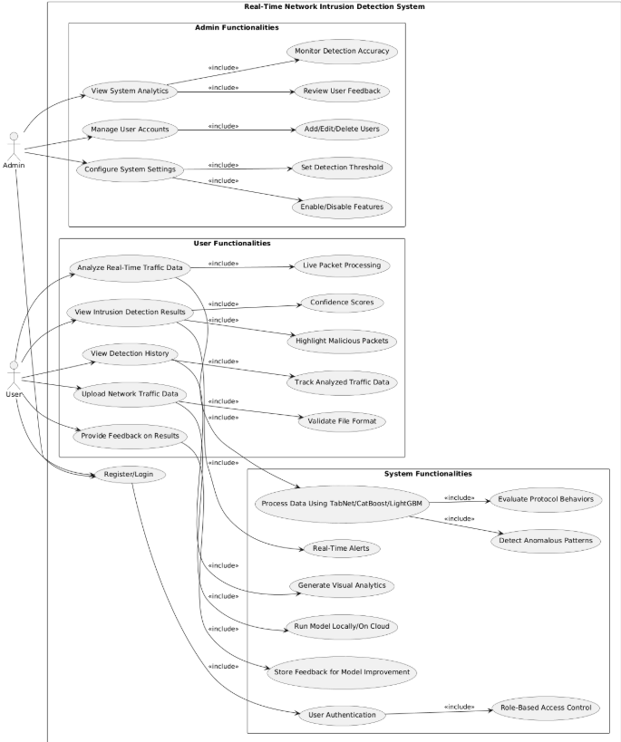

1.6.2 Usage Scenarios
The following usage scenarios correspond to the functionalities shown in the Use Case Diagram, capturing how different actors interact with the system to perform tasks such as registration, uploading traffic data, analyzing data, and monitoring system performance.

Use Case 1: Register/Login
- Use Case ID: UC1
- Actor: Admin, User
- Actions:
  - Navigate to the registration or login page.
  - Enter credentials.
  - System validates or registers the user.
  - Redirects to Admin/User dashboard upon success.
- Description: Enables secure access to the system for users and administrators.
- Pre-Conditions: User has access to the system and provides valid credentials.
- Post-Conditions: User is logged in or registered successfully.
- Author: Wasif Nawaz
- Exceptions: Invalid credentials; user already registered.

Use Case 2: Upload Network Traffic Data
- Use Case ID: UC2
- Actor: User
- Actions:
  - Select the option to upload a traffic file.
  - Browse and choose a valid CSV file.
  - System validates the file and initiates preprocessing.
- Description: Allows users to upload captured network traffic for analysis.
- Pre-Conditions: A valid CSV traffic file is available.
- Post-Conditions: File is uploaded, validated, and ready for analysis.
- Author: Samar Asad
- Exceptions: Unsupported file format or corrupted file.

Use Case 3: Analyze Real-Time Traffic Data
- Use Case ID: UC3
- Actor: User
- Actions:
  - Initiate live network analysis.
  - System captures traffic using Wireshark.
  - Data is preprocessed and analyzed in real-time.
- Description: Enables real-time detection of intrusions using live network data.
- Pre-Conditions: System access with active network interface and Wireshark installed.
- Post-Conditions: Results are displayed on the user dashboard.
- Author: Samar Asad
- Exceptions: Capture failure or real-time processing error.

Use Case 4: View Intrusion Detection Results
- Use Case ID: UC4
- Actor: User
- Actions:
  - Navigate to results section.
  - View detection outcomes and confidence scores.
- Description: Displays the results of the intrusion analysis in detail.
- Pre-Conditions: Traffic data must have been analyzed.
- Post-Conditions: Results are presented to the user.
- Author: Wasif Nawaz
- Exceptions: No data available to display.

Use Case 5: Provide Feedback on Results
- Use Case ID: UC5
- Actor: User
- Actions:
  - Submit feedback on result accuracy.
  - System stores the feedback for future model refinement.
- Description: Allows users to contribute to improving the detection model.
- Pre-Conditions: Results must be visible.
- Post-Conditions: Feedback is recorded in the system.
- Author: Wasif Nawaz
- Exceptions: Feedback not stored due to error.

Use Case 6: Configure System Settings
- Use Case ID: UC6
- Actor: Admin
- Actions:
  - Access configuration panel.
  - Modify thresholds and enable/disable features.
  - Save the changes.
- Description: Provides system administrators with control over system behavior.
- Pre-Conditions: Admin access rights.
- Post-Conditions: System configuration updated.
- Author: Samar Asad
- Exceptions: Failure to apply settings.

Use Case 7: View Detection History
- Use Case ID: UC7
- Actor: User
- Actions:
  - Access the history section.
  - View previous analysis records.
- Description: Allows users to review past intrusion detection outcomes.
- Pre-Conditions: At least one previous analysis must exist.
- Post-Conditions: Past results are displayed for user review.
- Author: Samar Asad
- Exceptions: No history available.

Use Case 8: Monitor Detection Accuracy
- Use Case ID: UC8
- Actor: Admin
- Actions:
  - Open system analytics dashboard.
  - Review detection accuracy, precision, and F1-score.
- Description: Enables admins to assess performance of the intrusion detection models.
- Pre-Conditions: Metrics must be recorded in the system.
- Post-Conditions: Performance data is displayed.
- Author: Wasif Nawaz
- Exceptions: Metrics not available or analytics failure.

1.7 Development Methodology
This section outlines the development approach used for building the Real-Time Intrusion Detection System. Due to the combination of stable planning needs and evolving technical requirements (especially in machine learning model training and testing), a hybrid development model was adopted. The selected model is the VU Process Model, which merges the sequential nature of the Waterfall Model with the iterative flexibility of the Spiral Model.

1.7.1 Chosen Methodology
In this project, a hybrid approach known as the VU Process Model has been adopted. It effectively combines the structured nature of the Waterfall Model with the iterative flexibility of the Spiral Model, resulting in a development methodology that is both disciplined and adaptable.

Waterfall Model
The Waterfall Model is a traditional, linear software development lifecycle (SDLC) methodology. It divides the entire process into discrete phases, each of which must be completed before the next one begins.
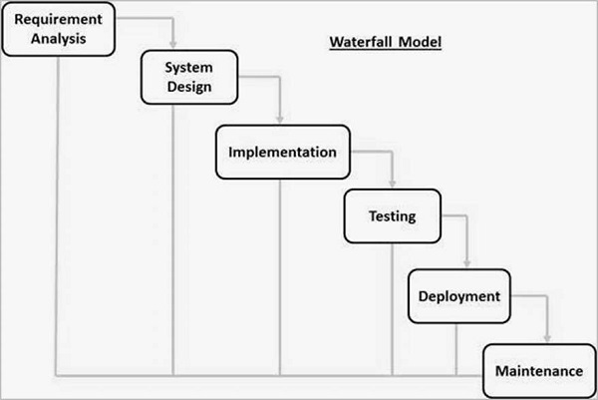
Phases of the Waterfall Model:
- Requirement Analysis – Gathering and documenting functional and non-functional system requirements.
- System Design – Architecting the system's components, data flow, and UI.
- Implementation – Coding the designed components and modules.
- Testing – Verifying and validating the developed system.
- Deployment – Delivering the final product to the end users.
- Maintenance – Addressing issues and applying updates post-deployment.
Advantages:
- Clear structure and documentation.
- Easy to manage and understand.
- Well-suited for projects with stable requirements.
Limitations:
- Not flexible for changes after development starts.
- Late discovery of issues (e.g., at testing or deployment phase).
- Not ideal for complex or research-intensive systems where requirements evolve.
Relevance to This Project:
The Waterfall approach supports the early planning of your IDS project—helping to define requirements, design architecture, and structure milestones. It’s especially useful for organizing documentation such as SRS, design documents, and test plans.

Spiral Model
The Spiral Model is a risk-driven software development process model that combines the iterative nature of prototyping with the controlled aspects of the Waterfall model. It is especially suited for large, complex, and evolving projects.
Phases in Each Spiral Cycle:
- Objective Setting – Define goals, features, and alternatives.
- Risk Assessment – Identify, analyze, and mitigate risks.
- Engineering and Prototyping – Build the product incrementally with feedback loops.
- Evaluation and Planning – Review outcomes and plan the next iteration.
Advantages:
- Encourages early and continuous risk management.
- Highly flexible and adaptive to changes.
- Supports incremental releases and evolving requirements.
- Strong focus on validation and stakeholder feedback.
Limitations:
- Can be expensive and complex to manage.
- May lead to extended development cycles if not well-controlled.
- Not suitable for small or tightly time-boxed projects.
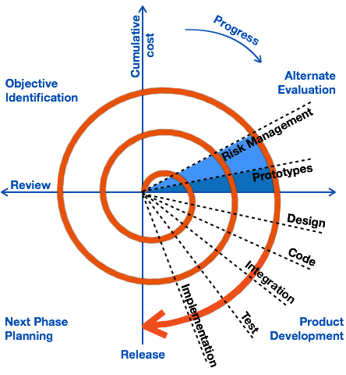

Relevance to This Project:
The Spiral Model enables iterative model training, continuous integration of new techniques, and adaptive fine-tuning—crucial for machine learning components in your IDS. It helps incorporate regular testing, evaluation, and risk mitigation, particularly when working with evolving datasets and tuning multiple ensemble models.

VU Process Model (Hybrid Approach)
The VU Process Model is a hybrid methodology recommended by the Virtual University of Pakistan, which integrates the Waterfall and Spiral models. It is specifically designed to align with both academic structure and practical software development requirements.
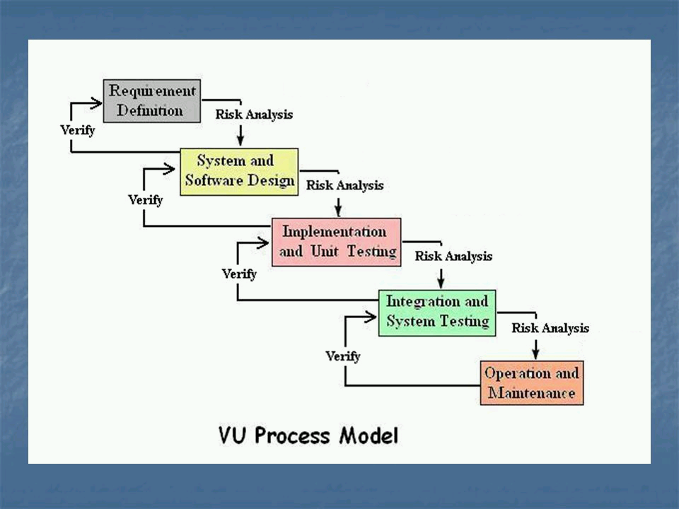
Model Structure:
- Phase 1: Requirement Analysis (Waterfall)
Document all system needs before design or coding begins.
- Phase 2: System Design (Waterfall)
Create architecture diagrams, data flow models, and GUI mockups.
- Phase 3: Development & Testing (Spiral)
Iteratively build the system in parts. Integrate ML models, perform testing, and refine based on outcomes.
- Phase 4: Deployment and Evaluation (Waterfall + Spiral)
Deliver final system. Gather feedback and apply final adjustments.
Advantages:
- Combines the predictability of Waterfall with the adaptability of Spiral.
- Provides structured milestones for academic tracking (e.g., SRS, Design Doc).
- Supports iterative model development and user testing cycles.
- Suitable for mid-scale projects like FYPs involving ML and web interfaces.
Why It Was Chosen:
- Offers a balance between structure and flexibility.
- Fits academic project deliverables and timelines.
- Allows for incremental development of ML models.
- Provides early planning and clear documentation.
- Reduces risk through iterative refinement and early testing.

1.7.2 Reasons for Chosen Methodology
The VU Process Model was selected for the following reasons:
- Balanced Approach: It provides a structured framework while supporting flexibility for iterative model improvement and GUI enhancements.
- Academic Alignment: Matches the required phases and document submissions (e.g., SRS, design document, mid-evaluation, final report).
- Risk Management: Allows risk identification and mitigation during the development and testing of ML models and web interfaces.
- Efficient Planning: Supports early planning of architecture, design, and functional modules.
- Iterative Enhancements: Facilitates gradual improvement of the system, especially important for data preprocessing, training, and evaluating ensemble models like TabNet, CatBoost, and LightGBM.
- Stakeholder Visibility: Encourages progress tracking, feedback integration, and clear communication between the team and supervisor.

1.7.3 Work Plan (Gantt Chart)

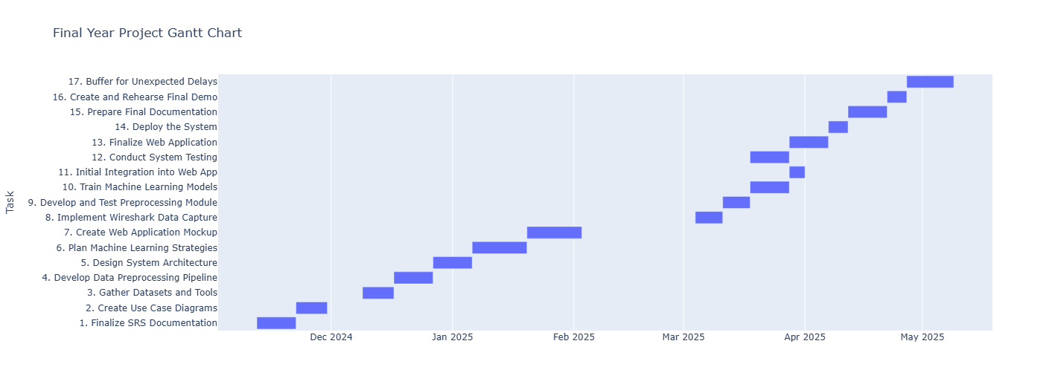

CHAPTER 2
Designing the Project

2.1 Introduction
This chapter outlines the design phase of the project, which serves as the blueprint for the system's technical implementation. It includes the system's logical and physical structure, data modeling, architectural components, and interface designs. The design phase ensures that all functional and non-functional requirements identified during the analysis phase are translated into a practical and scalable software architecture.
The main artifacts produced during this phase include:
- Entity Relationship Diagrams (ERD)
- Sequence Diagrams
- Architecture Design
- Class Diagrams
- Database Schema
- User Interface (UI) Prototypes
- Test Case Designs
These design elements guide the development and ensure consistency, reliability, and maintainability throughout the system's lifecycle.

2.2 Purpose
The purpose of the design phase is to define how the system will fulfill the requirements captured earlier. This includes making decisions about:
- System architecture (frontend, backend, machine learning layer)
- Data storage and relationships (ERD, database schema)
- Functional workflows (via sequence diagrams)
- User interface layouts and interactions
- Validation through test planning
A well-defined design helps minimize risks, reduce implementation errors, and improve development efficiency. For this project, design planning also supports modular integration of machine learning models and real-time analysis via a web application.

2.3 Scope
The design scope includes all technical specifications and planning needed to:
- Structure and manage network traffic data from Wireshark
- Process and feed it into trained ensemble models (TabNet, CatBoost, LightGBM)
- Deliver a secure, responsive, and intuitive web application for user interaction
The following elements are covered:
- Data Design: How network data is structured and stored
- Process Design: How user interactions lead to backend processes like uploading, classification, and results display
- Interface Design: Web-based components for user registration, file uploads, and result visualization
- System Design: Integration of machine learning models and real-time traffic analysis within a modular architecture

2.4 Definitions, Acronyms, and Abbreviations
Term / Abbreviation | Definition
ERD | Entity Relationship Diagram
UI/UX | User Interface / User Experience
ML | Machine Learning
CSV | Comma-Separated Values
Wireshark | Network protocol analyzer used to capture live traffic
TabNet | Deep learning model for tabular data
CatBoost | Gradient boosting algorithm developed by Yandex
LightGBM | Lightweight gradient boosting framework by Microsoft
Sequence Diagram | A type of UML diagram showing object interactions over time
Backend | Server-side part of the application handling logic and data
Frontend | Client-side part of the application visible to the user

2.5 Entity Relationship Diagram (ERD)
The Entity Relationship Diagram (ERD) defines how the core entities in the system interact with one another within the database structure. It models real-world components such as users, uploaded network traffic files, detection results, and feedback.
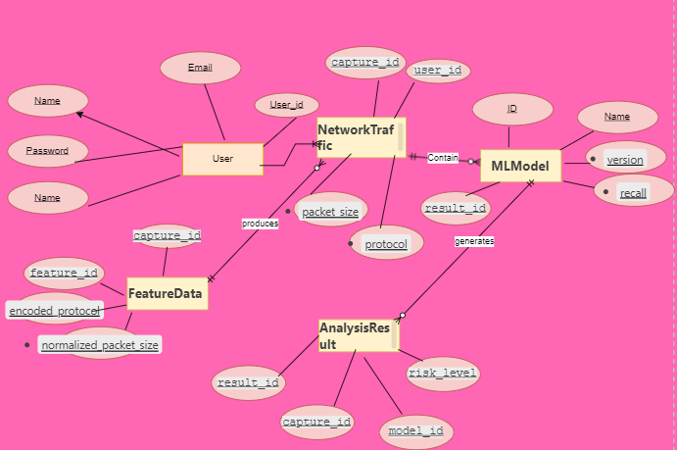

2.6 Dynamic Model: Sequence Diagrams
Sequence Diagrams illustrate the order of interactions between various system components during specific use cases.
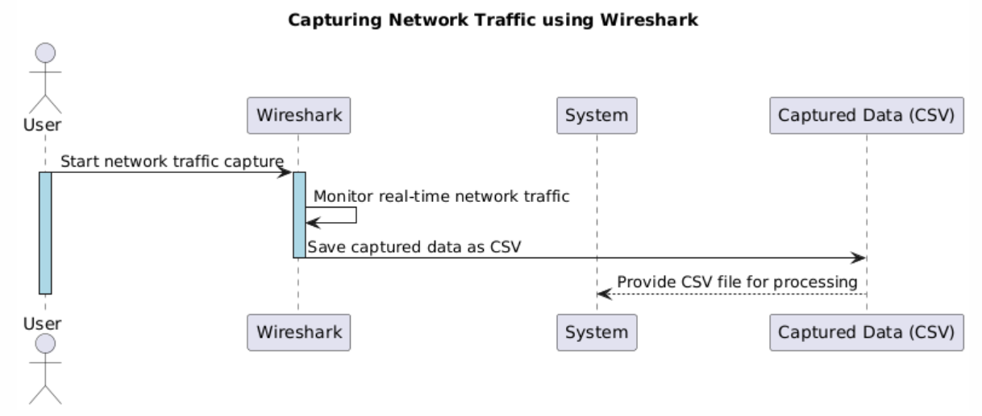

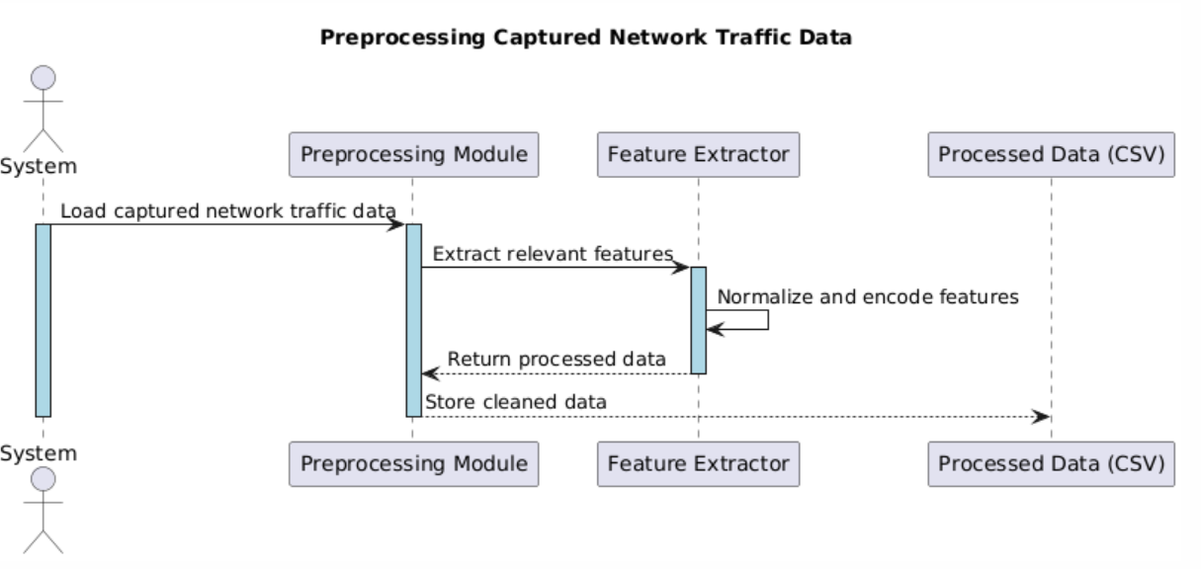

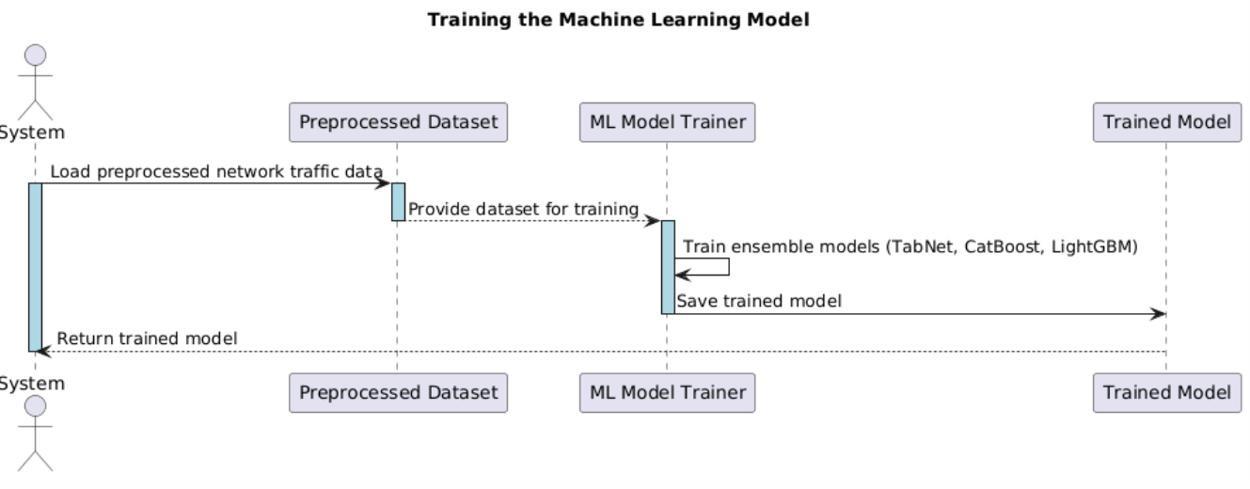

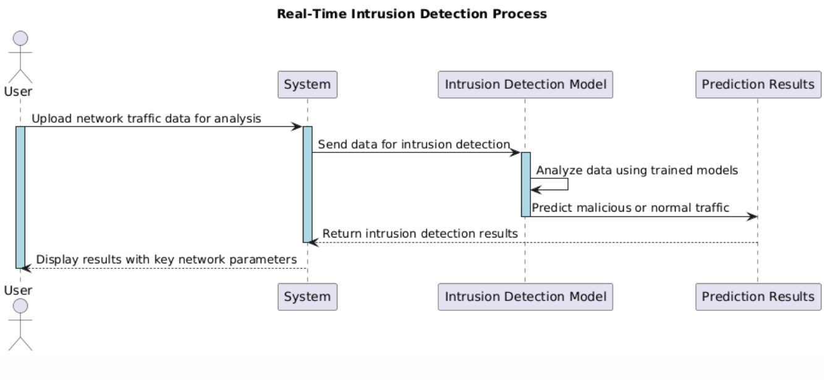

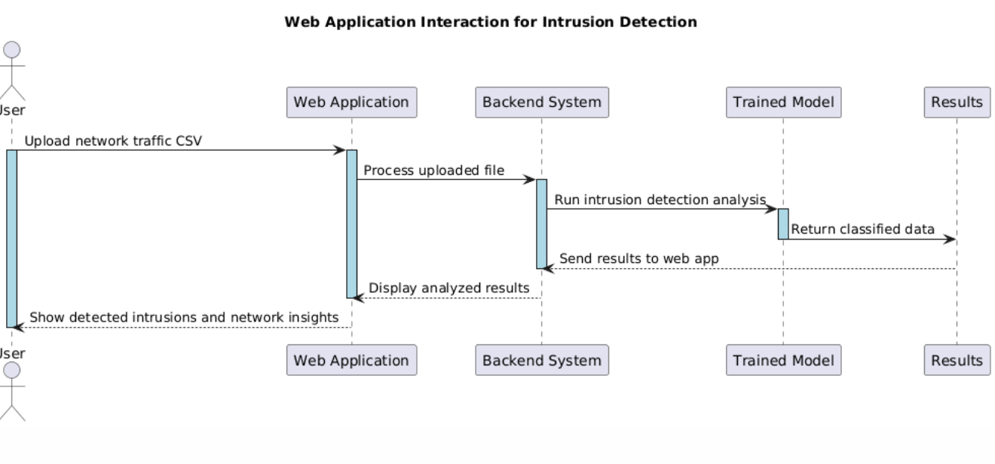

Diagram 1: Capture and Upload Network Traffic
- Actors: User, Wireshark, System, Captured Data (CSV)
- Sequence:
  - The User initiates the network traffic capture using Wireshark.
  - Wireshark monitors real-time traffic on the selected network interface.
  - The captured traffic is saved locally as a CSV file.
  - The System accesses the saved CSV and prepares it for preprocessing.
  - The CSV file is then forwarded for further analysis by the intrusion detection components.

Diagram 2: Preprocessing Captured Network Traffic Data
- Actors: System, Preprocessing Module, Feature Extractor, Processed Data (CSV)
- Sequence:
  - The System loads the captured network traffic data.
  - The Preprocessing Module processes the data and stores the cleaned data.
  - The Preprocessing Module extracts relevant features from the cleaned data.
  - The Feature Extractor normalizes and encodes the extracted features.
  - The processed data is saved as a CSV file for further analysis.

Diagram 3: Training the Machine Learning Model
- Actors: System, Preprocessed Dataset, ML Model Trainer, Trained Model
- Sequence:
  - The System loads preprocessed network traffic data.
  - The Preprocessed Dataset provides the dataset for training.
  - The ML Model Trainer trains ensemble models (TabNet, CatBoost, LightGBM).
  - The ML Model Trainer saves the trained model.
  - The System returns the trained model.

Diagram 4: Real-Time Intrusion Detection Process
- Actors: User, System, Intrusion Detection Model, Prediction Results
- Sequence:
  - The User uploads network traffic data for analysis.
  - The System sends the data for intrusion detection.
  - The Intrusion Detection Model analyzes the data using trained models.
  - The Intrusion Detection Model predicts whether the traffic is malicious or normal.
  - The System returns the intrusion detection results.
  - The User displays the results with key network parameters.

Diagram 5: Web Application Interaction for Intrusion Detection
- Actors: User, Web Application, Backend System, Trained Model, Results
- Sequence:
  - The User uploads a network traffic CSV file through the Web Application.
  - The Web Application forwards the uploaded file to the Backend System for processing.
  - The Backend System invokes the Trained Machine Learning Model to perform intrusion detection on the uploaded data.
  - The Model analyzes the data and returns classified results (e.g., normal or malicious).
  - The Backend System sends the analysis results back to the Web Application.
  - The Web Application displays detected intrusions and insights to the User.

2.7 Architecture Design Diagram
The Architecture Design Diagram presents a high-level view of how system components are connected and interact to perform key tasks.
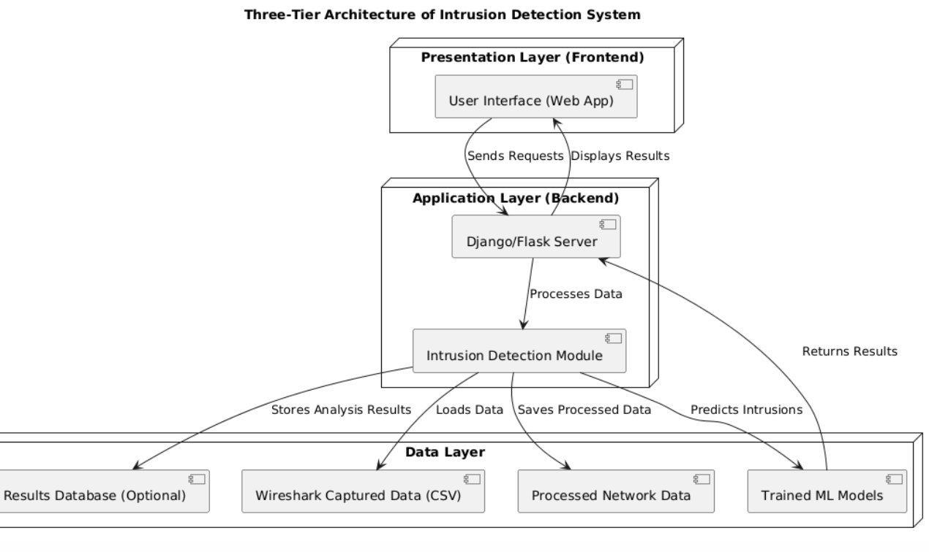

1. Presentation Layer (Frontend)
- Comprises the User Interface (Web App) developed using Flask or Django.
- Allows users to upload network traffic files, view results, and interact with the system.
- Sends user requests to the backend and displays the processed analysis results.

2. Application Layer (Backend)
- Powered by a Flask or Django server, this layer handles:
  - Input validation
  - Preprocessing of uploaded network data
  - Coordination of machine learning tasks
- Integrates the Intrusion Detection Module which invokes trained ML models and processes returned predictions.

3. Data Layer
- Responsible for data storage and model access:
  - Wireshark Captured Data (CSV): Raw traffic files uploaded by users.
  - Processed Network Data: Cleaned and transformed inputs used for model prediction.
  - Trained ML Models: Includes TabNet, CatBoost, and LightGBM.
  - Results Database (Optional): Stores classification results and user feedback.

The layered structure enables:
- Frontend to remain decoupled from logic-heavy backend processing.
- Backend to scale independently and manage resource-intensive tasks.
- Data and model layers to support efficient retrieval, reuse, and long-term storage.

2.8 Object Model / Logical Model: Class Diagram
The Class Diagram defines the logical and object-oriented structure of the software system.
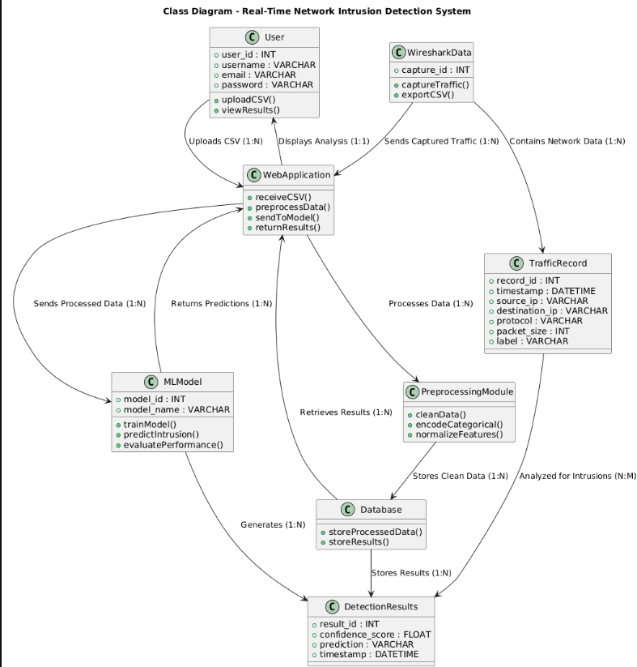

Representative Classes
- User
  - Attributes: user_id, username, email, password
  - Methods: uploadCSV(), viewResults()
  - Role: Manages authentication and system interaction. One user can upload multiple traffic files.
- WiresharkData
  - Attributes: capture_id
  - Methods: captureTraffic(), exportCSV()
  - Role: Captures and exports real-time network data via Wireshark.
- WebApplication
  - Methods: receiveCSV(), preprocessData(), sendToModel(), returnResults()
  - Role: Handles frontend-backend integration, manages data flow, and displays results.
- TrafficRecord
  - Attributes: record_id, timestamp, source_ip, destination_ip, protocol, packet_size, label
  - Role: Stores individual network packets captured and preprocessed for analysis.
- PreprocessingModule
  - Methods: cleanData(), encodeCategorical(), normalizeFeatures()
  - Role: Encodes and normalizes the uploaded network data to prepare it for machine learning analysis.
- MLModel
  - Attributes: model_id, model_name
  - Methods: trainModel(), predictIntrusion(), evaluatePerformance()
  - Role: Trains, evaluates, and uses machine learning models for intrusion detection (e.g., TabNet, CatBoost, LightGBM).
- Database
  - Methods: storeProcessedData(), storeResults()
  - Role: Stores cleaned network data and detection results.
- DetectionResults
  - Attributes: result_id, confidence_score, prediction, timestamp
  - Role: Logs the model's prediction outputs, which are shown to users through the web interface.

Key Relationships
- User → WebApplication: One-to-one for user interaction and dashboard access.
- User → WiresharkData / TrafficRecord: One-to-many (uploads and records).
- WebApplication → MLModel: Sends preprocessed data for prediction.
- MLModel → DetectionResults: Produces classification output stored in the database.
- PreprocessingModule → TrafficRecord: Processes raw traffic into structured form.
- Database → DetectionResults: Stores and retrieves prediction outcomes.

2.9 Database Model (Database Diagram)
The Database Diagram visually represents the system's relational schema and its structure.
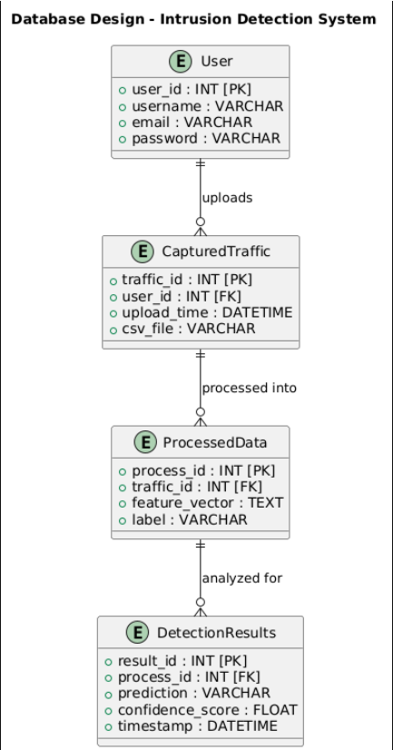

Key Tables and Relationships
- User
  - Fields: user_id [PK], username, email, password
  - Purpose: Stores user credentials and manages access control.
  - Relationships: One user can upload many traffic files.
- CapturedTraffic
  - Fields: traffic_id [PK], user_id [FK], upload_time, csv_file
  - Purpose: Stores metadata of each uploaded network traffic file.
  - Relationships: Each upload belongs to a user and may be processed into one or more entries.
- ProcessedData
  - Fields: process_id [PK], traffic_id [FK], feature_vector, label
  - Purpose: Stores preprocessed and labeled data extracted from uploaded files for model analysis.
  - Relationships: Each traffic file can have multiple processed records.
- DetectionResults
  - Fields: result_id [PK], process_id [FK], prediction, confidence_score, timestamp
  - Purpose: Stores the results generated by machine learning models after analyzing processed data.
  - Relationships: Each processed record can generate a corresponding detection result.

Key Features of the Schema
- Referential Integrity: Foreign keys ensure that records are traceable back to the originating user and uploaded file.
- Normalization: Each table handles a specific data responsibility, reducing redundancy and improving query efficiency.
- Extensibility: The model can be extended to include additional tables such as:
  - feedback: To collect user input on prediction accuracy.
  - logs: To maintain audit trails and monitor system events.

2.10 Graphical User Interfaces
The web-based application was developed using the Flask framework, with a focus on usability, clarity, and functionality. All components follow responsive design principles, ensuring accessibility across various screen sizes and devices. The interface is intuitive and well-organized, making it suitable for both technical and non-technical users.

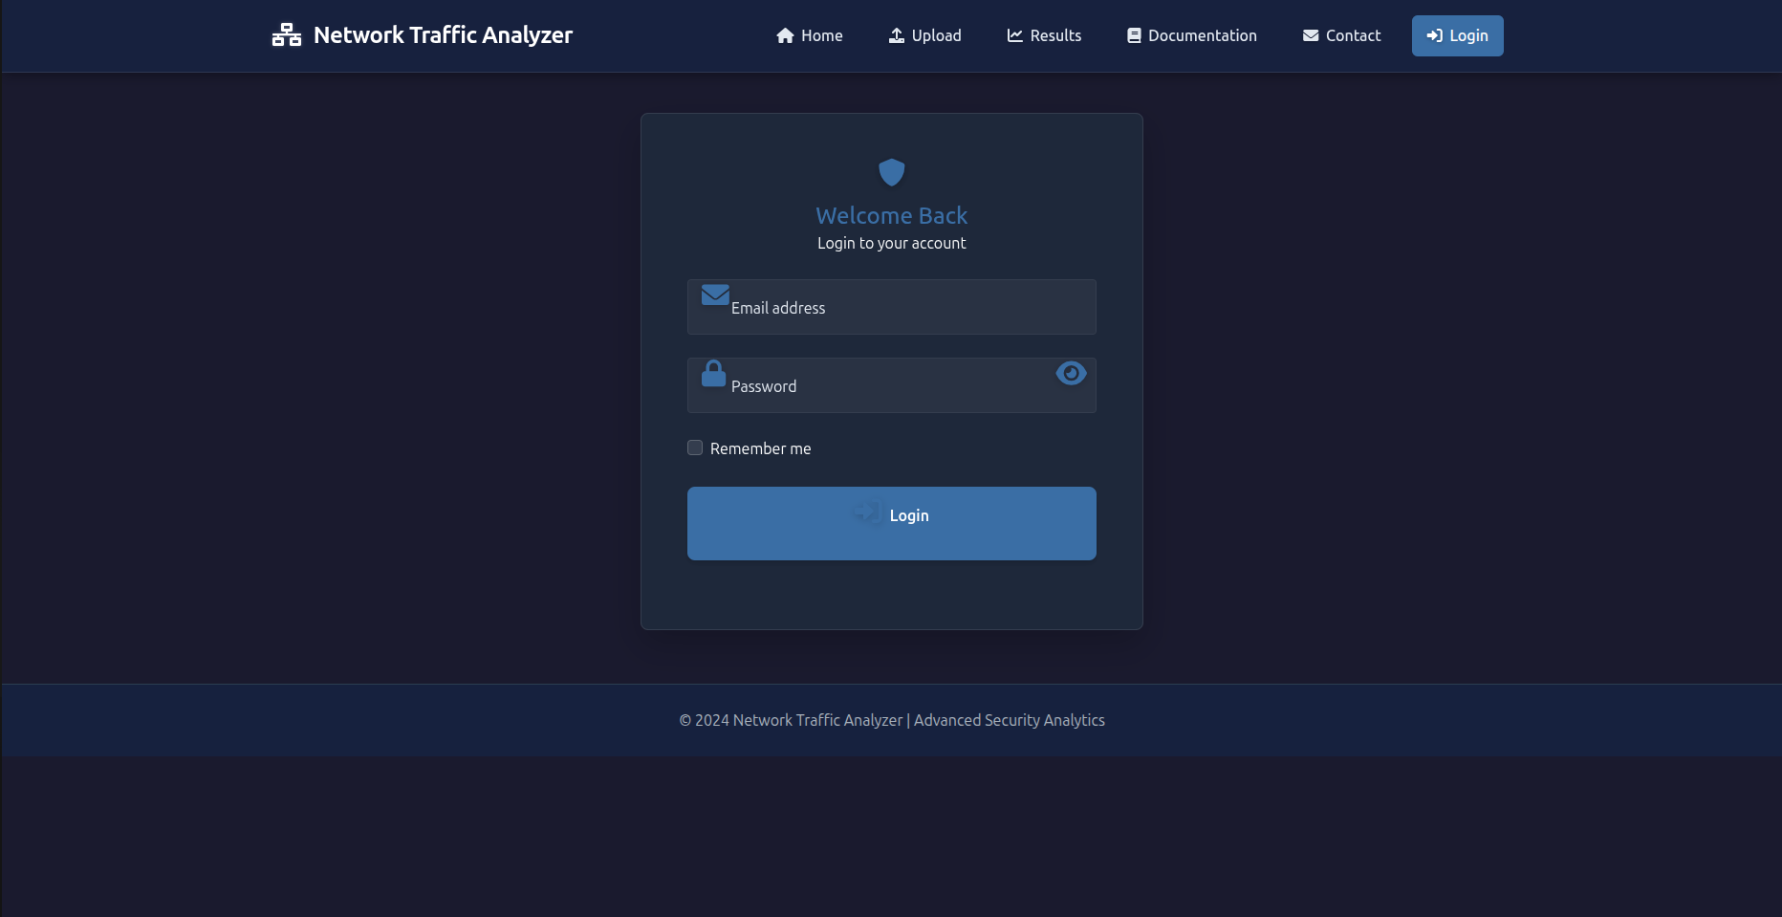


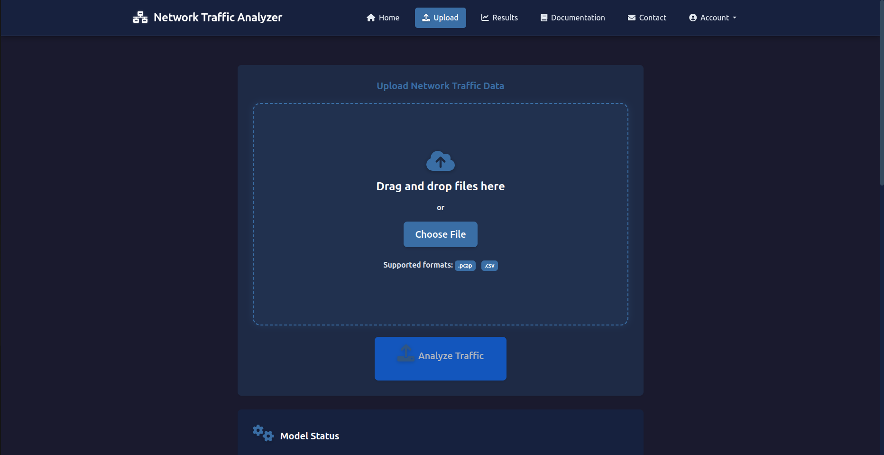
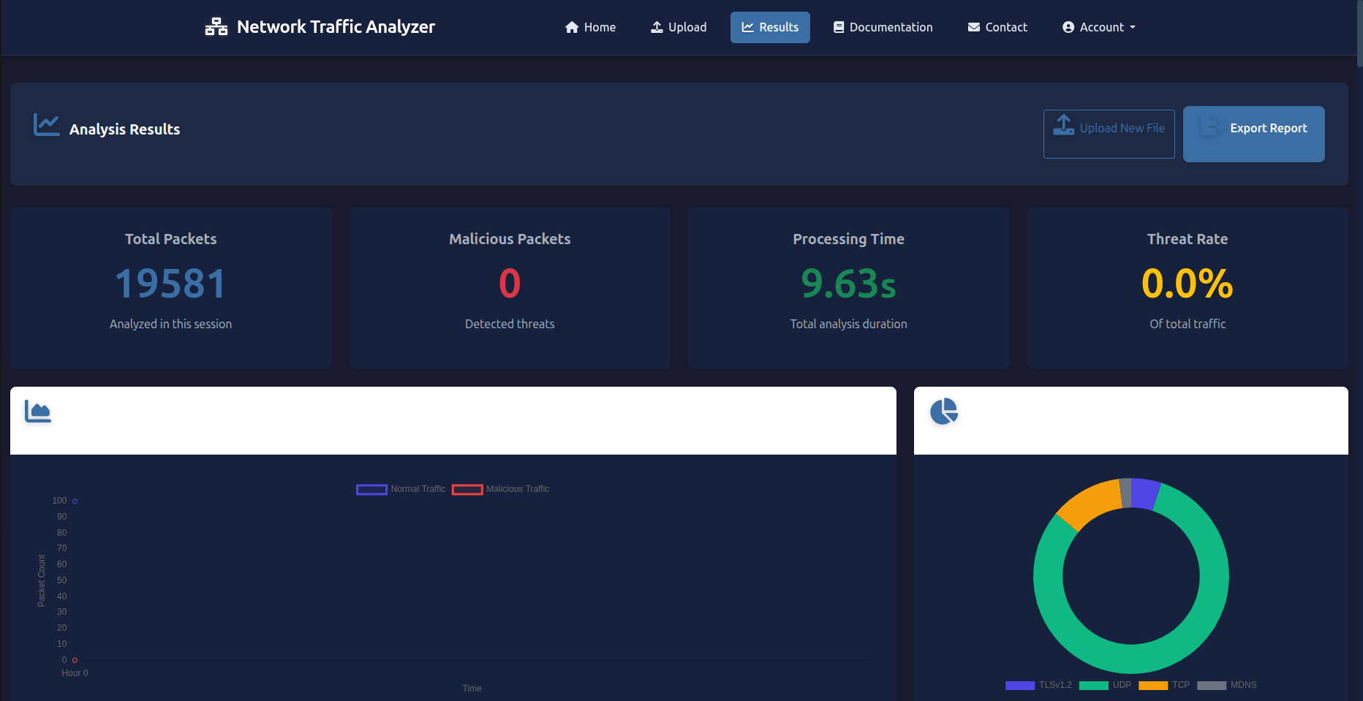
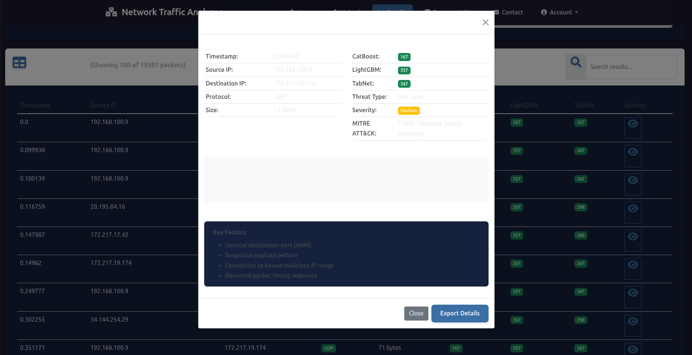
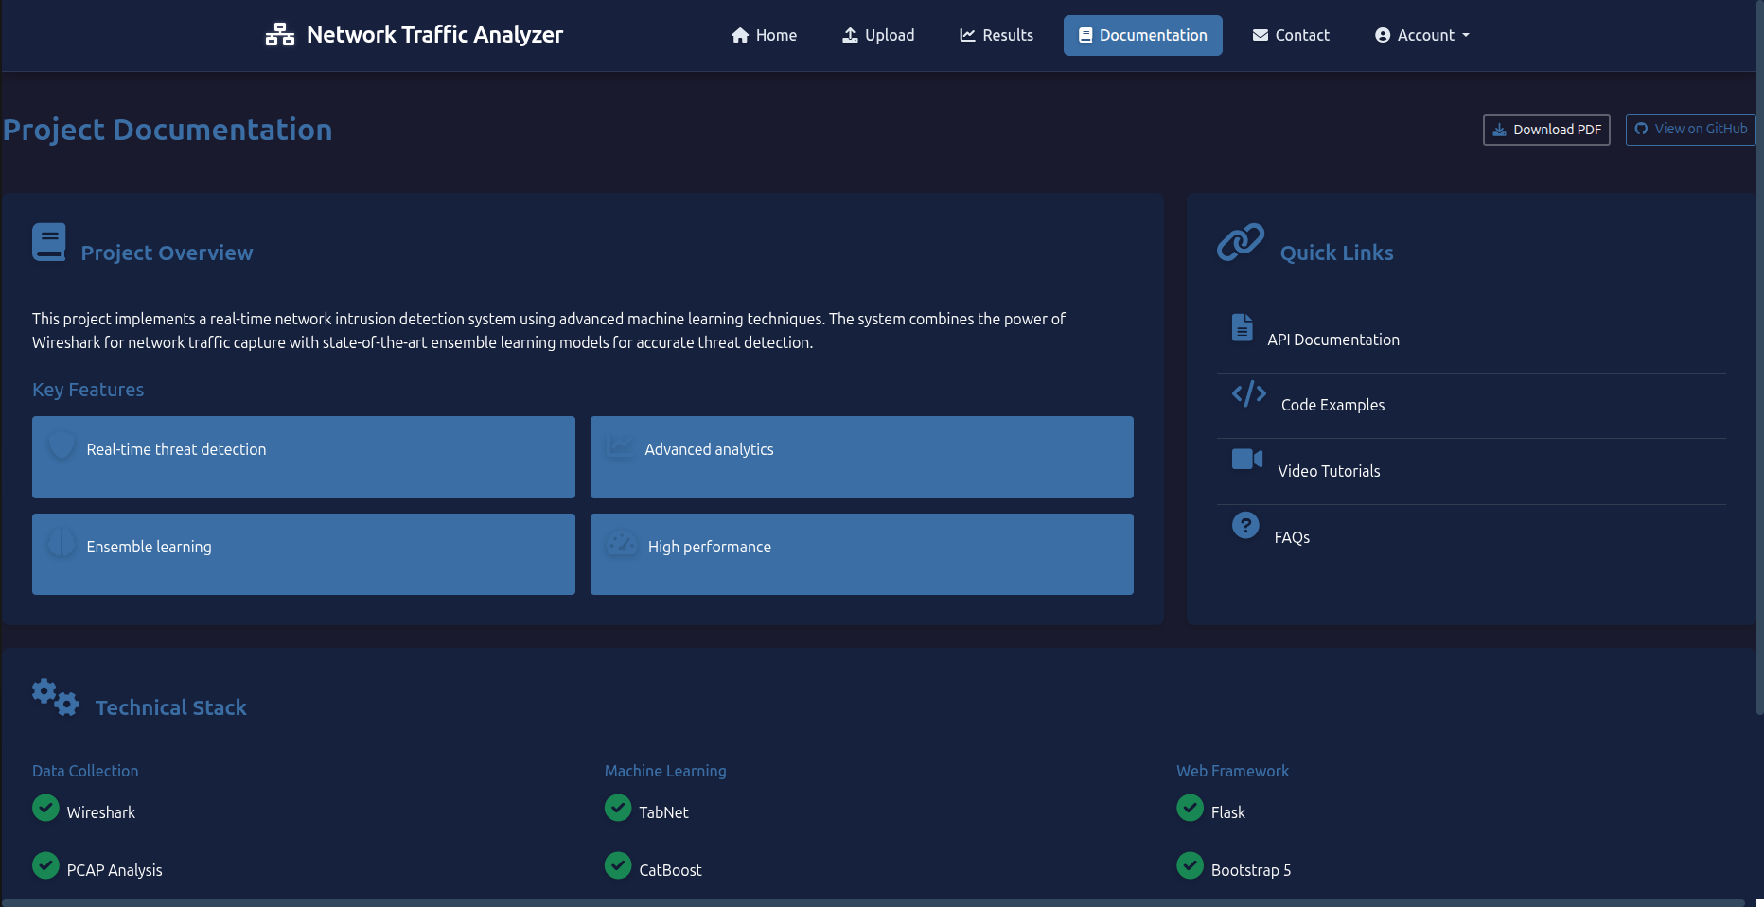
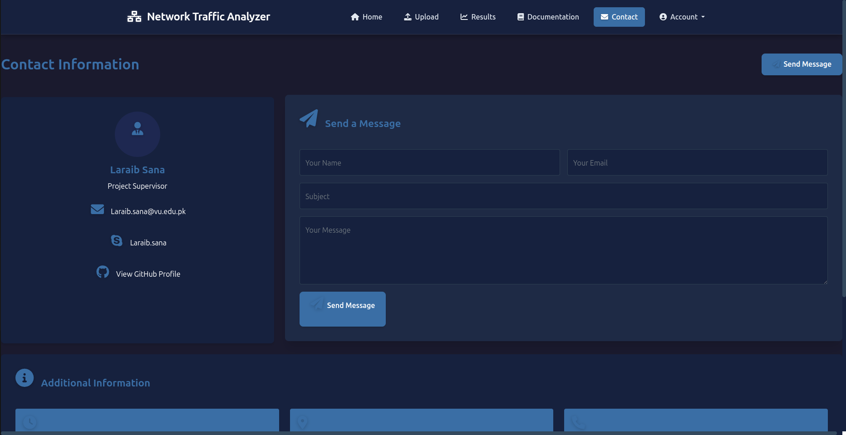
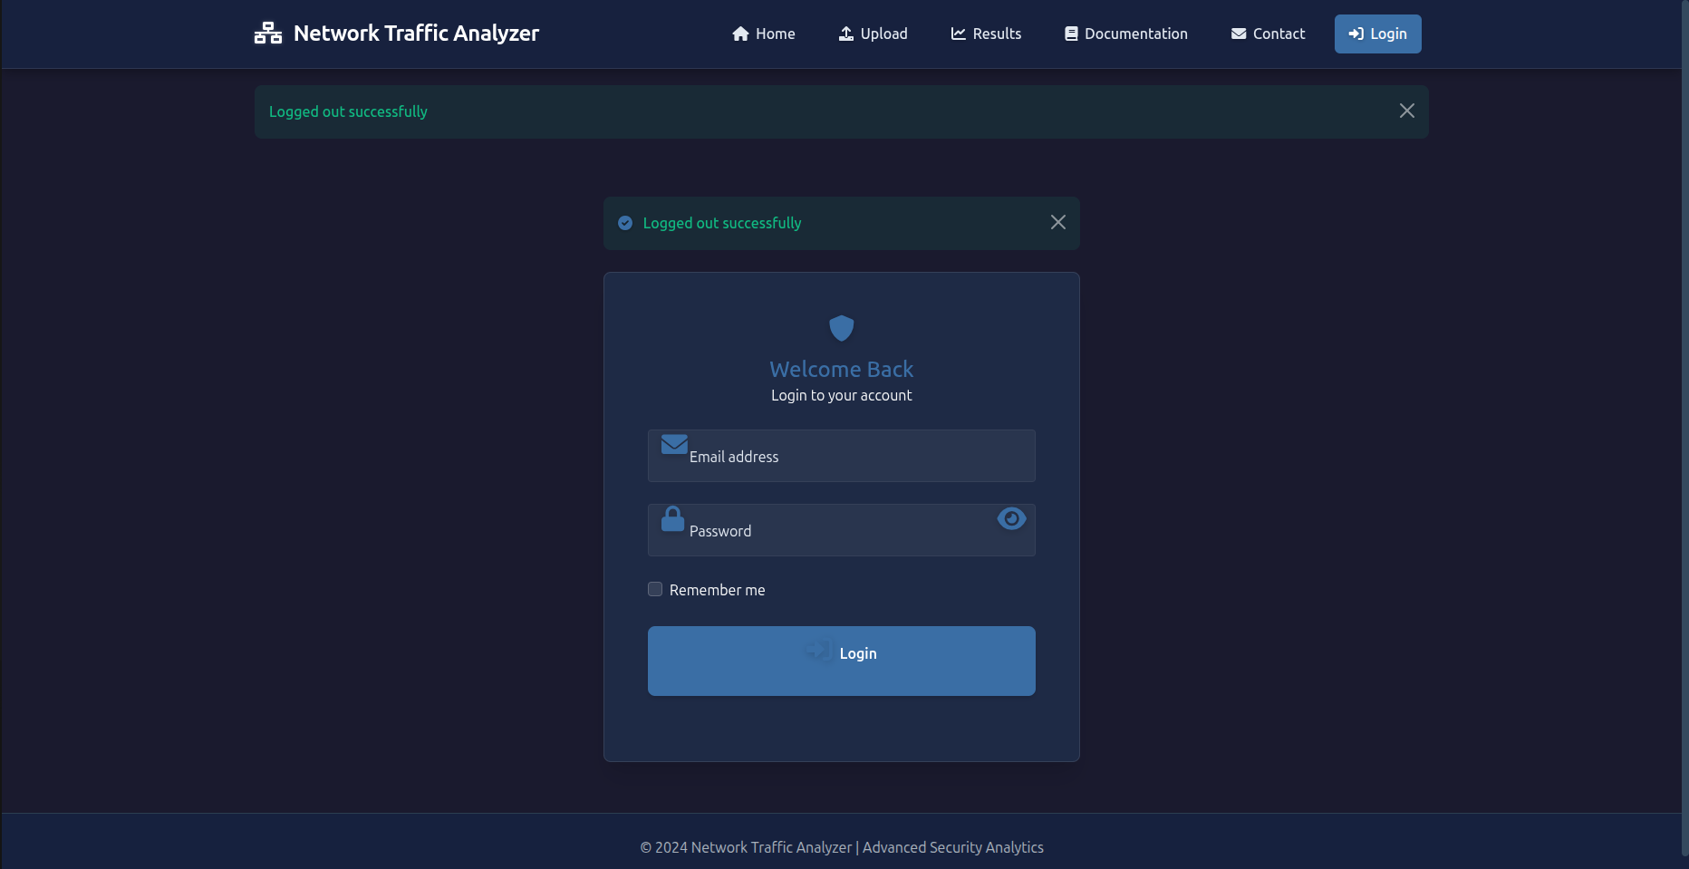

Main GUI Components

1. Login Page
- Secure authentication system using email and password.
- "Remember me" feature for session persistence.
- Flash notifications for successful or failed login attempts.

2. Home Dashboard
- Central navigation hub post-login.
- Displays system status indicators (e.g., model loading status).
- Quick access buttons for file upload, documentation, and support.

3. Upload Interface
- Supports CSV file uploads with drag-and-drop functionality.
- File validation checks to ensure format is .csv only.
- Displays model availability (TabNet, CatBoost, LightGBM).
- Maximum file size limit set to 50MB.

4. Results Viewer
- Displays detailed analysis of uploaded traffic data:
  - Total number of packets analyzed.
  - Number of malicious packets detected.
  - Processing time in seconds.
- Tabular view of packet-level predictions from all three models.
- Pagination for large datasets (initially shows first 100 rows with load-more option).

5. Documentation Section
- Contains reference material on system usage.
- Descriptions of the ML models and detection process.
- Help on understanding analysis results and metrics.

6. Contact Page
- Developer contact information and support links.
- Option for users to submit feedback or report issues.

7. Error Handling Pages
- Custom-designed 404 (Page Not Found) and 500 (Server Error) pages.
- Informative error messages for issues like invalid file types or system processing failures.

CHAPTER 3
Development

3.1 Introduction
This chapter presents the practical implementation of the Real-Time Network Intrusion Detection System. It details the development journey, describing how each component was designed, integrated, and brought to life. The system follows a modular architecture, enabling seamless integration of real-time network capture, machine learning-based intrusion detection, and a user-friendly web interface.
Each module plays a specific role within the overall functionality of the system—from capturing raw network traffic using Wireshark, to preprocessing and feature extraction, model training and classification, and finally delivering analysis results through a web interface. This chapter documents how these components were developed and integrated into a cohesive and scalable solution.

3.2 System Implementation Overview
The system was implemented using a three-tier architecture, ensuring a clean separation of concerns between the presentation, application, and data layers. Here’s a brief overview of each layer's implementation:
- Presentation Layer (Frontend): A Flask-based web interface allows users to upload network traffic files, initiate real-time analysis, and view detection results.
- Application Layer (Backend): Responsible for handling file validation, data preprocessing, model invocation, and result formatting.
- Data Layer: Includes storage of captured data, processed features, detection results, and trained machine learning models.
The implementation process followed the VU Process Model, starting with structured planning, followed by iterative development and continuous integration of feedback and testing at each stage.

3.3 Tools and Technologies Used
The development of the system required a combination of networking, machine learning, and web development tools. Below is a list of key tools and technologies:
Category | Technology/Tool
Programming Language | Python
Traffic Capture Tool | Wireshark
ML Libraries | Scikit-learn, CatBoost, LightGBM, PyTorch-TabNet
Web Framework | Flask
Data Preprocessing | Pandas, NumPy
Data Visualization | Matplotlib, Seaborn
IDE | PyCharm, Jupyter Notebook
Version Control | GitHub
Database | SQLite / MySQL
Diagram Tools | Draw.io, Lucidchart, MySQL Workbench

3.4 Module-wise Development
The system was developed in distinct, interdependent modules to ensure maintainability and scalability. Each module was individually tested and then integrated into the main system.

3.4.1 Data Capture Module (Wireshark Integration)
This module enables real-time network traffic capture through Wireshark. Users can capture live packets using a graphical interface or command-line instructions. Captured data is exported in .pcap format and then converted to a .csv file for compatibility with preprocessing and ML stages.
Core Functionalities:
- Interface selection and capture initiation
- Saving network packet data in CSV format
- Handling large capture files for high-volume networks
Output: CSV file containing IP addresses, ports, protocol types, packet size, and timestamps.

3.4.2 Data Preprocessing and Cleaning Module
This module handles data transformation to prepare it for model training and analysis. It includes feature selection, encoding, and normalization.
Preprocessing Steps:
- Cleaning: Removing null, duplicate, and irrelevant values
- Encoding: Transforming categorical variables (e.g., protocol types)
- Normalization: Scaling numeric features like packet size and time intervals
- Labeling: Assigning 'normal' or 'malicious' labels for supervised learning
Tools: Pandas, Scikit-learn preprocessing utilities
Output: Cleaned and labeled dataset in structured CSV format.

3.4.3 Machine Learning Model Training Module
This module is responsible for training and evaluating the ensemble learning models used for intrusion detection.
Models Used:
- TabNet: Deep learning model for tabular data
- CatBoost: Gradient boosting library optimized for categorical features
- LightGBM: High-performance gradient boosting framework
Training Features:
- Split data into training and testing sets
- Train models on labeled traffic
- Evaluate with metrics: accuracy, precision, recall, F1-score, ROC-AUC
- Save models using joblib or pickle for deployment
Outcome: Trained models with high-performance scores, ready for use in the detection module.

3.4.4 Intrusion Detection and Classification Module
This module uses trained models to analyze uploaded or live-captured traffic and classify it as normal or malicious.
Detection Pipeline:
- Load trained models
- Accept real-time or uploaded traffic data
- Apply preprocessing transformations
- Predict using selected ensemble model
- Return prediction with confidence score
Performance Goals:
- High detection accuracy (95%+)
- Fast response (within 2–3 seconds per file)
Output: Classified results displayed to the user.

3.4.5 Web Application Interface
The web interface allows users to interact with the system in a simple and intuitive manner. Built using Flask, it bridges the gap between technical functionality and user accessibility.
Interface Features:
- Login and role-based access (Admin/User)
- File upload with validation
- Real-time analysis and result display
- Feedback submission system
- Admin analytics dashboard to view model performance
Design Considerations:
- Responsive layout for cross-platform compatibility
- Simple navigation and clean data visualization
- Secure handling of user data and uploaded files

3.5 Integration of Modules
Once the individual modules—data capture, preprocessing, machine learning model training, classification, and web interface—were developed and tested in isolation, they were integrated into a unified system. The integration was carried out in a stepwise manner to ensure seamless communication between components.
Integration Steps:
- Data Flow Connection: The CSV files generated by Wireshark were passed to the preprocessing module, ensuring correct file format and encoding compatibility.
- Model Invocation: The backend system was configured to dynamically load trained models (TabNet, CatBoost, LightGBM) and use them for predictions.
- Web-to-Backend Routing: Flask endpoints were set up to handle user file uploads, trigger the preprocessing pipeline, and fetch classification results.
- Database Linking: The web app communicated with the SQLite/MySQL database to store user details, file metadata, processed features, and detection outcomes.
- Result Feedback Loop: User-submitted feedback on prediction results was stored and made available for future model refinement.
Testing During Integration:
- End-to-end testing was conducted for all possible user actions (upload, view results, feedback).
- Logs were implemented to track errors and identify data flow issues.
- Integration was validated using both static datasets and live captured traffic.

3.6 Deployment Details
The system was deployed on a local development environment during implementation and can be easily adapted for cloud-based deployment if required.
Deployment Architecture:
- Backend: Hosted on a Flask server running locally or on a Linux VM (Python environment).
- Frontend: HTML templates rendered using Jinja2 (Flask) accessible via browser.
- Database: SQLite used for lightweight storage; MySQL option available for production-level scaling.
- Wireshark: Installed on the host system for real-time packet capture.
- ML Models: Stored in serialized formats (.pkl, .joblib) and loaded at runtime for inference.
Future Deployment Options:
- Host the application on Heroku, PythonAnywhere, or AWS EC2.
- Store models and large data files on S3 buckets or Google Cloud Storage.
- Integrate Docker for environment portability and version control.

3.7 Challenges and Mitigation Strategies
During the development of the system, several challenges were encountered. Below is a summary of the key issues and the strategies used to overcome them:
Challenge | Description | Mitigation Strategy
Data Volume | Large packet captures slowed down processing | Limited capture size; implemented batch preprocessing
Feature Complexity | Some packet fields were inconsistent or sparse | Feature selection and engineering to remove noise
Model Performance | Overfitting in early training attempts | Applied regularization and cross-validation
Integration Bugs | Mismatch in expected input format between modules | Created standardized data interfaces (CSV schema, encoders)
Real-Time Latency | Slight delay in prediction | Optimized model loading and minimized preprocessing steps
UI Responsiveness | Initial templates lacked clarity | Redesigned UI with Bootstrap for clarity and responsiveness

3.8 Summary
This chapter detailed the practical implementation of the Real-Time Network Intrusion Detection System. It covered:
- The development process across five key modules
- The technologies and tools utilized
- The integration of these modules into a unified pipeline
- Deployment practices and encountered challenges
The system is now capable of capturing real-time traffic, preprocessing and analyzing it using powerful ensemble models, and presenting actionable results to users through an intuitive web interface. These efforts have resulted in a reliable, scalable, and user-friendly solution for network intrusion detection.

REFERENCES

- Wireshark Foundation. (2023). Wireshark: Network protocol analyzer. Retrieved from https://www.wireshark.org
- Pedregosa, F., Varoquaux, G., Gramfort, A., Michel, V., Thirion, B., Grisel, O., ... & Duchesnay, É. (2011). Scikit-learn: Machine learning in Python. Journal of Machine Learning Research, 12, 2825–2830.
- Dorogush, A. V., Ershov, V., & Gulin, A. (2018). CatBoost: Gradient boosting with categorical features support. arXiv preprint arXiv:1810.11363.
- Ke, G., Meng, Q., Finley, T., Wang, T., Chen, W., Ma, W., ... & Liu, T. Y. (2017). LightGBM: A highly efficient gradient boosting decision tree. Advances in Neural Information Processing Systems, 30, 3146–3154.
- Arik, S. Ö., & Pfister, T. (2019). TabNet: Attentive interpretable tabular learning. arXiv preprint arXiv:1908.07442.
- Flask Documentation. (2024). Flask: Web development, one drop at a time. Retrieved from https://flask.palletsprojects.com
- Python Software Foundation. (2024). Python programming language. Retrieved from https://www.python.org
- Seaborn Developers. (2024). Seaborn statistical data visualization. Retrieved from https://seaborn.pydata.org
- Matplotlib Development Team. (2024). Matplotlib: Visualization with Python. Retrieved from https://matplotlib.org
- Virtual University of Pakistan. (2023). Final Year Project Guidelines - CS619. Retrieved from https://www.vu.edu.pk

APPENDIX

The appendix provides supporting materials and technical references that complement the main content of this report. It includes a summary of the tools, libraries, datasets, and samples that were used or developed during the course of this project.

Appendix A: Tools and Technologies Summary
Tool/Technology | Purpose
Python | Primary programming language for development
Wireshark | Real-time network traffic capture
Flask | Web application development framework
Scikit-learn | Machine learning preprocessing and evaluation tools
LightGBM | Gradient boosting model for high-performance training
CatBoost | Handling categorical features with boosting
PyTorch-TabNet | Deep learning for tabular data
Pandas / NumPy | Data handling and transformation
Matplotlib / Seaborn | Data visualization and analytics
Postgre | Relational database management
Jupyter Notebook | Model training, exploratory data analysis
GitHub | Version control and collaborative development
Draw.io / Lucidchart | Diagram creation (ERD, Class Diagrams, Architecture)
Microsoft Project | Gantt chart and project schedule

